Given the root of a binary tree, the level of its root is 1, the level of its children is 2, and so on.

Return the **smallest** level X such that the sum of all the values of nodes at level X is **maximal**.

**Example 1:**

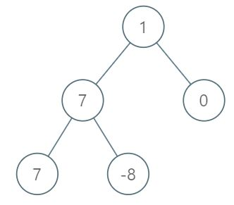

**Input:** [1,7,0,7,-8,null,null]

**Output:** 2

**Explanation:**

Level 1 sum = 1.

Level 2 sum = 7 + 0 = 7.

Level 3 sum = 7 + -8 = -1.

So we return the level with the maximum sum which is level 2.

**Note:**

1. The number of nodes in the given tree is between 1 and 10^4.
2. -10^5 <= node.val <= 10^5